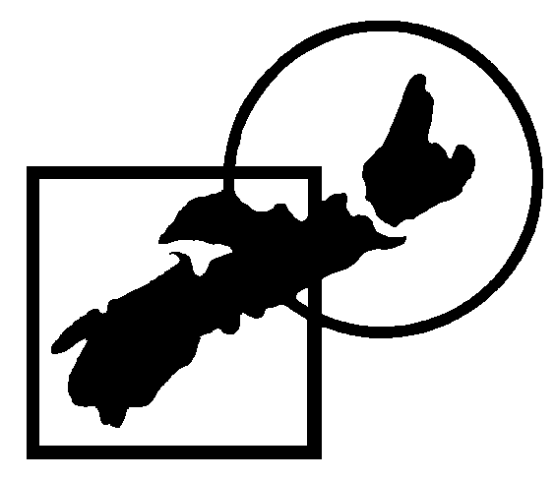
Square & Round Dance Federation of Nova Scotia
CLUB MEMBERSHIP ROSTER
Club: _________________________________________ Date: ______________________________________
We have listed the names sent to us last year. Please OK, Edit, Delete, or Add as appropriate.
For the insurance, we need to know who the Officers and/or Executive are (if any) and who the Leaders are (Callers and Cuers).
If individuals want to receive SRDFNS Calendar and other mailings they should provide an e-mail address and say “yes” in the “send info” box.
If possible, please return this list and the registration form as attachments to an e-mail sent to all three addresses below.
dwelch@eastlink.ca, ralph.macdonald@xplornet.com, prlangille@eastlink.ca
Otherwise send with club registration payment to Russ and Mary Trimper, 42 MacCormacks Lane, Eastern Passage, NS, B3G 1A3

Caller / Cuer (s): _______________________________
SRDFNS Contact: __________________________________
Is the Club is run by an Executive? ________ If so, please list the names of the officers:
President / Chair: _________________________
Vice President / Vice Chair: _________________________
Secretary: _________________________
Treasurer: _________________________

Note: This year the SRDFNS will pay the $3.00 CSRDS membership for callers, cuers, prompters and their partners.

OK  Edit  Del.  Add | Dancer’s  First Name | Dancer’s Last Name | E-mail (optional) | Send  Info  (y/n) | Date Started Dancing  yyyy-mm | Programs Danced | Club  Where  Insured | Other  Clubs
To add additional lines place cursor to the right of the line end and press return.

