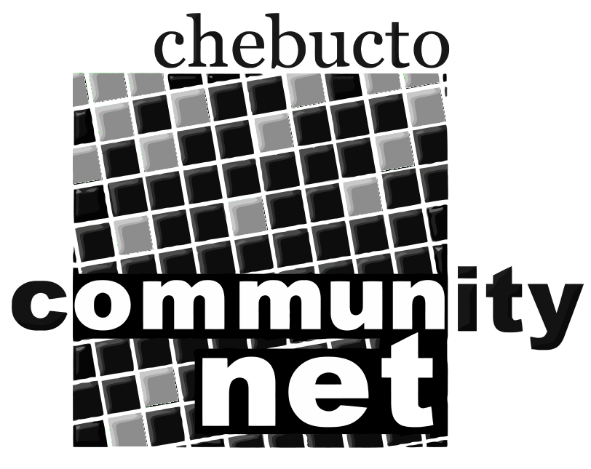 | Chebucto Community Net  Annual General Meeting  April 14, 2016
Treasurer's Report
Financially our year 2015 very much resembled 2014, the one exception being that in 2014 we received a lot of grant money, and in 2015 we spent it on the appropriate projects. We had hoped that as the Manors projects came online our membership would begin to grow again, but as you have, or will, learn from other reports various things prevented this from happening, and we ended the year with a slightly lower membership.
However we are still afloat and pursuing our mission of ensuring that no-one is prevented by their circumstances from receiving access to the Internet. This is becoming so much a part of everyone's life that some countries have included it in the rights of citizenship.
When you look at our statement you realize that virtually all our income is derived from membership fees; and our expenditures are entirely on what is necessary to provide members with access to the Internet. We have only one employee (still voluntarily receiving only half his appointed salary) and everything else is achieved by the efforts on unpaid volunteers.
We remain hopeful that at some time some level of government will recognize the value of this work and provide us with grants to enable us to do an even better job. In the meantime we will continue to put our best efforts into providing as good a service as possible.
Alan Turner
Treasurer
Chebucto Community Net Society

