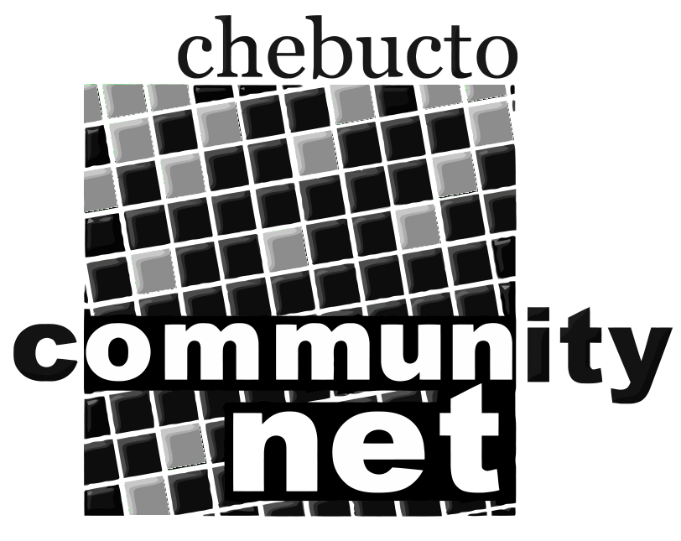 | Chebucto Community Net  Annual General Meeting  April 14, 2016
Report from the Chair of the
Board of Directors
The Manors Project has continued to dominate the agenda of your Board of Directors over the past year. After completing work on HP MacKeen and Joseph Howe Manors we moved on to three North-end residences: Gordon B Isnor, Ahern and Sunrise Manors.

To reach the North-end Manors we need to have a signal from the roof of Dalhousie's Tupper Medical Building. We have signed a legal agreement with Dalhousie covering our access to this space. But the process of finalizing the conditions has been agonizingly slow. Fortunately, we are now in the position of having cleared the last hurdle Dalhousie has placed before us and work should begin soon on installing the equipment.

I want to acknowledge the contribution of a person who has played a central role in this project. Dave Johnston is a skilled technician who makes his living installing wireless systems for paying clients. With MacKeen, Joseph Howe and the North-end Manors he has donated his time and expertise to Chebucto. Even more, he has convinced others, sometimes members of his own family, sometimes other skilled trade people to donate their time and services. He has been an indispensable source of informed opinion on what equipment purchases would be best for us. At this time, it is appropriate that we express and record our thanks to Dave for his contribution. The Manors Project would not have happened without him.

There is other good news on the Manors. The Halifax Region Community Access Program (HRCAP) has obtained grants to provide Tablets and user training to residents of HP MacKeen and Joseph Howe Manors. Those residents will receive a Chebucto login for which HRCAP will pay Chebucto $100 per Tablet. This is good news for both organizations but especially for HRCAP which has suffered severe funding cuts over the past several years.

At its March meeting, the Chair of HRCAP broached the idea that, should HRCAP's financial position deteriorate further, a merger between that organization and Chebucto might be considered. This is very much in the "idea" stage at the moment and will require serious consideration by the incoming Board of Chebucto.

Another item requiring the new Board's attention will be the current salary status of our office manager. In 2009, at his own suggestion, the Board placed Andrew on half-pay. Chebucto's financial situation was poor at the time. Even so, the Board made this decision with great reluctance and with the understanding that it would be a temporary, stop-gap measure. Seven years later, Andrew is still on half-pay, there having been only two brief periods when the Board temporarily was able to restore him to full salary. This is a situation which should not be allowed to continue and will be a major concern for the incoming Board.

During the past year we have moved ahead with taking a serious look at methods and procedures for delivering Chebucto's services. A sub-committee of the Board was struck and charged with looking at this area and bringing forward recommendations. At our March Board meeting, sub-committee Chair Doug Brown presented a report detailing several recommendations, including: creation of a disaster recovery plan, creation of a technical backup archive, establishment of a recovery procedure and making the technical service less totally dependent on the Technical Director by sharing access to passwords. All recommendations were accepted by the Board. We are grateful to the sub-committee for their work.

We have continued to maintain a prominent media presence, especially through Twitter, and are now considered a go-to source for media wishing comment on issues relating to affordable Internet access. In a Chebucto "first" our office manager will be travelling to Gatineau, Quebec later this month to make a presentation to the CRTC on the importance of affordable Internet access and Chebucto's activities in providing this service.

This will be my last report to the Annual General Meeting and I want to thank the current members of the Board as well as those with whom I have served in the past. They are some of the best people I've known. I would also like to thank you, the membership, for giving me the opportunity to serve.

Marilyn MacDonald
Chair
Board of Directors
Chebucto Community Net Society

