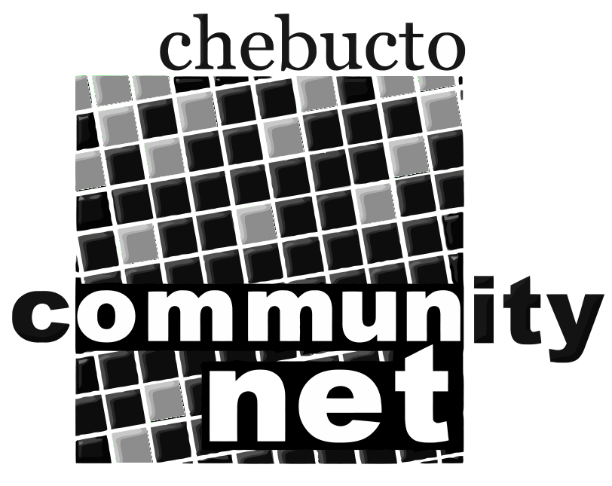 | Chebucto Community Net  Annual General Meeting  April 23, 2014
Technical Report
Manors Project
After years of effort, the project to bring low cost wireless Internet access to has finally taken physical form. In spring of 2013 wireless access points were installed in Joe Howe and H.P. MacKeen Manor, enabling residents unrestricted high-speed access to the Internet courtesy of the Chebucto Community Net.
The wireless service has been in operation for nearly a year now and we are quite pleased with the results. The system has been very stable, requiring little maintenance, and routinely handles over 50 simultaneous wireless sessions.
We are currently in the process of upgrading our authentication system to handle login requests to the wireless network.
Heartbleed
On April 7th, 2014 a vulnerability in popular encryption software OpenSSL was made public knowledge. The bug (dubbed "Heartbleed") could allow a remote attacker access to some data in system memory of the server running OpenSSL. Chebucto Community Net uses OpenSSL to encrypt certain network traffic to and from our servers, such as secured email access and web site access.
Chebucto Community Net took several actions following reports of the Heartbleed bug. We immediately updated the vulnerable OpenSSL software on our servers to a version which is not susceptible to the bug. Administrative passwords to the affected servers were changed, and a new security key was generated along with a corresponding security certificate.
While we have no evidence that any personal information was leaked from our system due to the Heartbleed bug, the stealth with which Heartbleed operates makes this hard to determine.
Funding
Last year Chebucto Community Net was approved to receive funding from the HRM District 7 "District Capital Fund". These funds will be used to upgrade and improve Chebucto's infrastructure including new servers, data backup, and networking equipment.
Currently, Chebucto Community Net has also submitted grant proposals to the Canadian Network for the Advancement of Research Industry and Education (CANARIE) and the Canadian Internet Registration Authority's (CIRA) Community Investment Program.

Johnathan Thibodeau
Technical Director
Chebucto Community Net

