 | Chebucto Community Net  Annual General Meeting  April 17, 2013
Technical Report
New Mail Storage Server
In early February of this year, and after years of effort a new server replaced Chebucto’s failing mail storage server. Installed in 2007 and built from recycled hardware, the previous mail storage server, named copia, was plagued with an increasing number of hardware issues. At the time it was installed, the server marked a dramatic change in how Chebucto handles e-mail, and allowed us to increase quotas to 1GiB for many users. But in more recent years, slow mail retrieval and frequent outages told of the old system’s age.
“Why build one when you can have two at twice the price?”
The new storage server, named fortuna, was built with new hardware. It has greater storage capacity, more memory, and faster processors than its predecessor. The new server will also receive a ‘twin’ in the not-too-distant future; another server built to the same specifications which will work in concert with the new server. Together, the two servers will offer greater mail access speeds and service redundancy.
Networking Switch Upgrade
Generously donated by Fresh Group Atlantic, Chebucto installed a new core networking switch to service the servers in our machine room. The networking switch routes Internet data to and from our servers, user connections, and the Internet at large. The new networking switch has many new features above our old networking switch, such as traffic shaping/routing and IPv6 support. These features will be necessary to support the launching of our new wireless service.
IPv6
At current the majority of data on the Internet is delivered using the IPv4 (Internet Protocol version 4). However IPv4 addressing resources are becoming scarce and so servers are slowly being migrated to the replacement protocol: IPv6. With the installation of our new networking switch, Chebucto is working on updating our servers to the IPv6 protocol. Members should not notice any disruptions as we move to the new standard, and IPv4 will still be supported for the foreseeable future as IPv6 adoption across the entire Internet will take many years yet.

Security

Chebucto’s primary web server has received a much needed security software update. The new software has increased the strength of the server’s encryption and eliminates the risk of certain well known attacks that have been discovered in recent years. Strong encryption is used to protect membership renewals made online, as well as usernames and passwords when logging into Chebucto’s services.
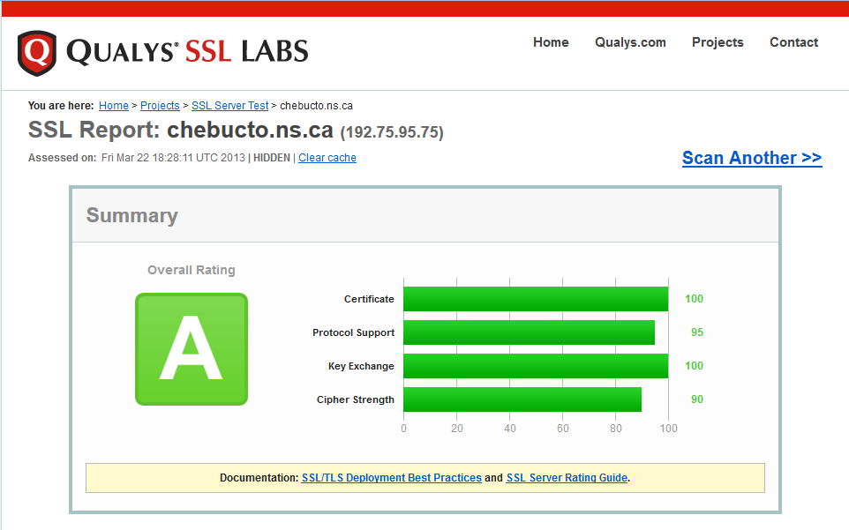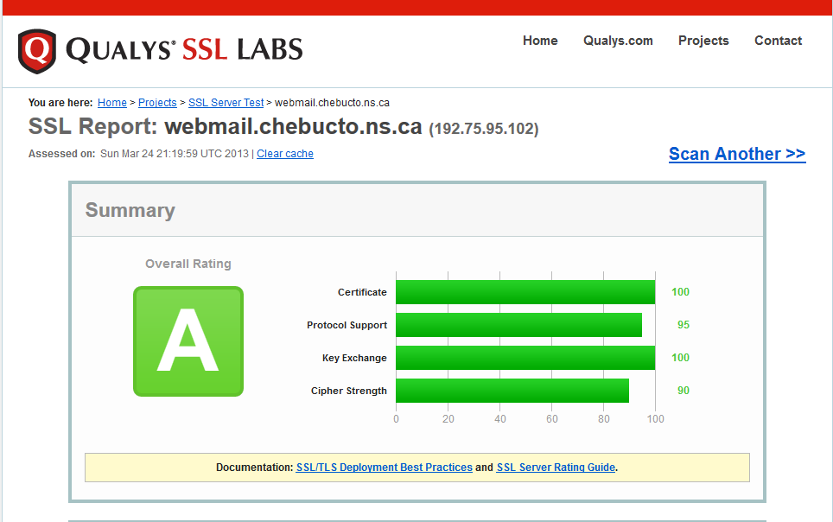

Johnathan Thibodeau
Technical Director
Chebucto Community Net

