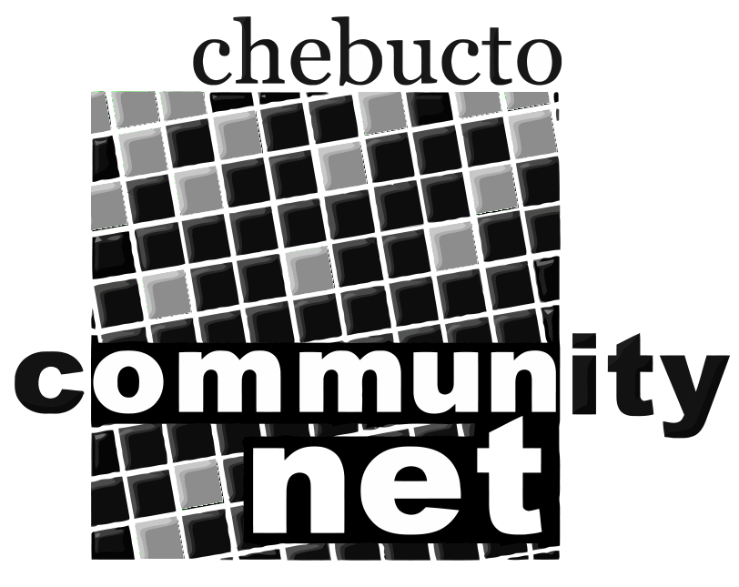 | Chebucto Community Net  Annual General Meeting  April 27, 2011
Technical Report
Joseph Howe Wireless Project
Work on the Joseph Howe Wireless Project has been put on hold while our technical crew completes the required training and certification for installing communication cables in residential and commercial buildings. The issue of certification was raised at a CCN board meeting, and it was felt that the staff should receive the proper training to continue work on the wireless project.
Power Outages
Major renovations to a Dalhousie building required that the electricity to the Chase Building (where CCN is located) be shut down on numerous occasions from November 2010 to January 2011. Some of these outages were short enough that we were able to run on battery power for the duration, but frequently the power outages required that our services be shut down for several hours. On one occasion, a large generator was rented to cover a 12+ hour power outage.
Planned Mail Upgrades
It has been just over 4 years since CCN moved to a new mail system, providing larger, faster, and more reliable mailboxes for all CCN users. (See the Beacon news story: http://www.chebucto.ns.ca/news/Old-News/news-2007-03-24.shtml ). In order to keep our mail system current, we are now sourcing parts for newer, faster equipment to replace the system which has served us so well in the past.
LSC / Chase Building Flood
On July 24th, 2010 there was an explosion and fire on the roof of the neighbouring Life Sciences Centre which resulted in major flooding, spilling into the basement of the Chase Building where CCN's computer systems reside. The water level rose to 7”-9" in the Chase, requiring the electricity to the machine room to be turned off for 24 hours while damage was assessed. Fortunately, all of CCN's equipment is mounted several inches off the floor and nothing was damaged during the flood.
Johnathan Thibodeau

