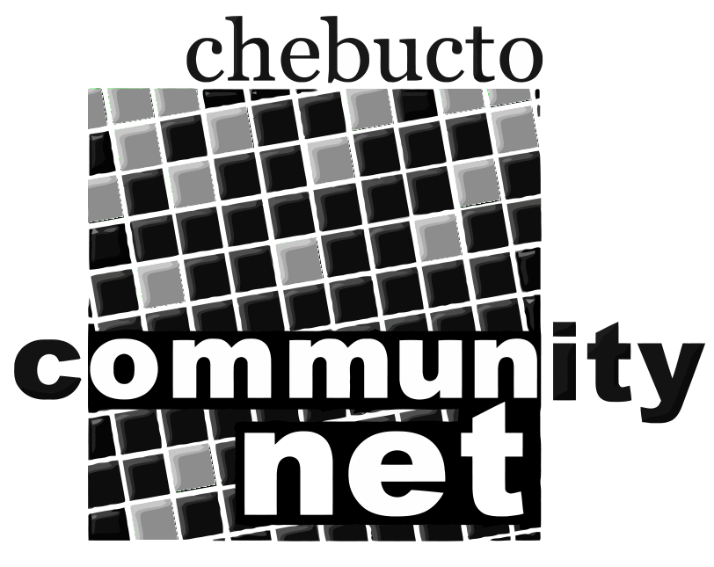 | Chebucto Community Net  Annual General Meeting  April 27, 2011
Chebucto Community Net Society
Minutes of the 2010 Annual General Meeting
29 April 2010
Members who arrived before the 7:00 PM meeting time were treated to double screen images of Nova Scotia from the air courtesy of Richard Bonner, who brought his own computer and a CD of aerial images to share with those present.
Bernie Hart called the meeting to order at 7:15 PM.
The minutes of the 2009 Annual General Meeting were circulated. Michael Marshall moved acceptance of the minutes, seconded by Alan Turner. Carried.

Report from the Chair (by Bernie Hart, Chair)
This past year, Chebucto’s fifteenth year of operation, was a time to reflect on our initial mission and to look at the challenges in ahead.
The Board made a concerted effort to bring Chebucto Community Net and its services to the attention of municipal and provincial politicians. Meetings with two local MLAs Graham Steele and Leonard Preyra and with two inner city councillors Dawn Sloane and Sue Uteck were cordial and Board members who attended were left with the understanding further discussions would be welcome. In October Chebucto’s Vice Chair, Marilyn MacDonald gave a presentation to the HRM Council as a whole during at formal Council meeting.
When the media began to discuss Canada’s lag behind other countries vis-a-vis Internet service in general and accessibility to digital communication, CCN saw an opportunity to facilitate discussion on the situation at the local level. A series of Town Hall discussions, which is still underway, was developed.
Chebucto resumed its membership in the Community Access Program (CAP) after a lapse of several years. This and our continuing membership in the Atlantic Canada Organization of Research Networks (ACORN) are both positive connections with like-minded organizations.
The members of Chebucto as well as the staff and Board deserve a sincere thank you. Each one of you plays a vital role in maintaining Chebucto. I look forward to seeing each of you at a similar meeting next year.
Bernie Hart moved acceptance of his report. Seconded by Marilyn MacDonald. Carried.

Policy Committee Report: (Andrew Wright)
The role of the policy is two-fold: to address policy development and implementation issues; and, to address complaints or abuses about and by CCN members.
2009 was a quiet year for the committee, there was no need to amend any policies and no new policies were required.
The only cases of abuse involved members whose accounts had been compromised when they responded to scam emails claiming to be CCN and asking for passwords. Members were reminded never to respond to email requesting their passwords.

Technical Committee: (Johnathan Thibodeau)
The volume of spam continues to rise; CCN receives about 1.5 million such messages a day. Five servers are presently dedicated to filtering out spam and other junk emails. The system in place scans about three thousand messages per minute, but frequent ‘gusts’ of incoming spam can cause delayed mail as the servers work through an excessive number in the queue.
Earlier this year the process by which the mail scanners work was altered so that much of the mail which would previously been tagged as spam, and delivered into the JUNKMAIL folder is now rejected outright. The decision of whether or not to block an incoming message is based on Real-time Block lists (RBL), a technology which has long been used to determine whether or not an email is from a ‘trustworthy’ host. The RBL system has proven very helpful, the volume of spam which must be scanned by CCN’s servers is significantly less, and less spam is forwarded through our system and this is particularly important because many CCN accounts forward mail to another email provider.
Implementation of the wireless project was delayed due to the sale of Fenwick Tower to a private developer. All equipment was removed from the roof of Fenwick: wireless equipment will be installed in the roof of Gerard Hall a student residence on the Sexton campus; and, webcam will be placed on roof of the Life Sciences Building on the main Dalhousie campus. We will be able to implement wireless project for Joe Howe Manor soon after the equipment is installed on Gerard Hall.
Alan Turner moved the acceptance of the both the Policy and Technical Committee reports. Seconded by Richard Bonner. Carried.

Financial Report: (Alan Turner, Treasurer)
The financial outcome of 2009, a deficit of $4500 was very close to the figure predicted in the budget. Renewal were not forthcoming, membership continued to fall and in spite of the increase of fees from $100 to $125 per year Chebucto’s income from memberships fell by $6000. Chebucto continues to function because Andrew was paid half salary through the year and Johnathan in mid year accepted a full time position at Dalhousie and has been handling the necessary technical workload on a volunteer basis since that time.
Alan Turner moved acceptance of the Treasurer’s report. Seconded by Marilyn MacDonald. Carried.

Appointment of Auditor:
Andrew Wright moved that Chebucto continue with the current auditor, Joanne DesRosiers. Seconded by Alan Turner. Carried.

Election of Directors:
Mary Rigby presented a slate of four new members to the Board: Terry Dalton, Deborah Dostal, Dan Robichaud and Mary Ansell. Having no additional nominations from the floor hence no requirement for a vote, the four were declared members of the Board.
Directors for 2020-2011 are thus serving members: Alan Turner, Bernie Hart, Kent Murray, Marilyn MacDonald, Jeff Warnica, Richard Connolly, and Johnathan Thibodeau, and newly elected members Terry Dalton, Deborah Dostal, Dan Robichaud and Mary Ansell.

Other Business:
Bernie Hart noted retiring Board member, Michael Marshall, spearheaded the Town Hall program in an attempt to bring the state of the Internet services and the Digital Divide in Canada and locally to the attention of the general public. The initial one held at Dalhousie University in conjunction with the Student Union in November, involved a broad panel of five people. Three of CCN’s own people, two Board members and Andrew Wright gave a joint presentation at the regional library in Spryfield in March. The format of the Spryfield will be followed in three presentation scheduled for May 8, May 26 and June 9 at Woodland, Alderney landing and Bedford regional libraries respectively.
Retiring Board member Joe Thomas was instrumental obtaining two grants, which assisted Chebucto to purchase equipment. Both grants came from Emera, which provides such funds to community groups, that their former staff members support.
Bernie thanked both Michael and Joe as well Mary Rigby, who as acted as secretary during her tenure on the Board.

Adjournment:
Alan Turner moved the meeting be adjourned.

Presentations focused on Internet accessibility and the Digital Divide:
Andrew Wright and Michael Marshall presented effectively illustrated Powerpoint presentations focused on the cost and accessibility of the Internet in Canada and in Nova Scotia. Both speakers brought a number of interesting and at times disturbing aspects about the present status of our Internet service and our lag behind other countries and regions.

Mary Dwyer Rigby

