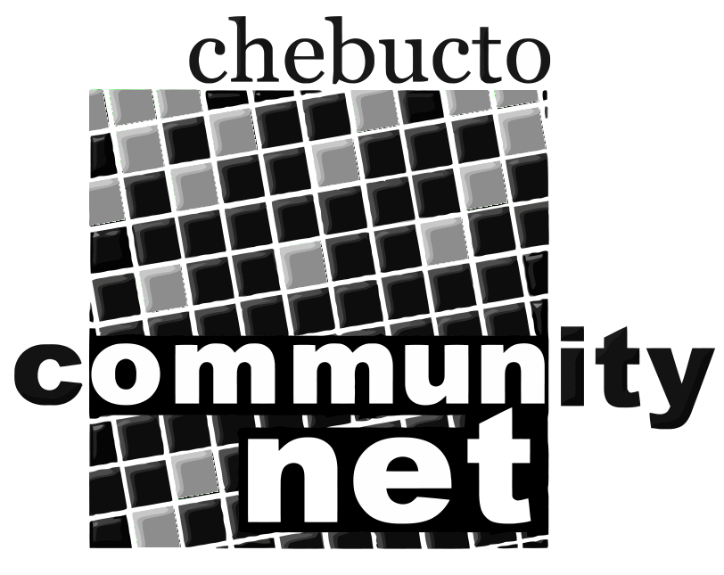 | Chebucto Community Net  Annual General Meeting  April 29, 2010
Technical Report

Spam and Mail Delays:
With spam volumes continuing to rise every day (up to 1.5 million messages a day for CCN), more and more resources need to be dedicated to its removal. Last year, the Department of Mathematics and Statistics at Dalhousie University donated a server which was placed in-line with CCN's other mail scanning servers bringing the total up to five servers dedicated to filtering out spam and other junk email.
Even with five servers continuously scanning for junk mail, frequent 'gusts' of incoming spam can cause delayed mail as the servers work through the queue of all incoming mail. CCN's mail scanners can scan mail at a rate approaching three thousand messages per minute, but spam and phishing attacks can push the incoming rate to over nine thousand messages per minute, causing the incoming queue to grow.
Earlier this year, the process by which the mail scanning servers scan mail was reworked so that much of the mail which would have been tagged as spam, and delivered into the JUNKMAIL folder, is now outright rejected before it is accepted by the mail scanners. The decision of whether or not to block an incoming message is based on Real-time Block Lists (RBL), a technology which has long been used to determine whether or not an email is from a 'trustworthy' host.
This new method has several benefits:
* The volume of mail which is accepted and scanned for spam is significantly reduced, allowing the mail scanners to employ more lengthy and thorough scanning techniques. These scanning practises were not previously feasible, as it would not allow for the mail scanners to keep up with the rate of incoming mail.
* RBLs were previously used to tag email as spam. Using RBLs to block messages means that ONLY messages previously destined for the JUNKMAIL folder are affected, and does not result in an increase of false positives.
* Rejecting an email falsely tagged as spam is better than sending it to the JUNKMAIL folder. Rejecting an email will cause a message to be sent back to the sender, notifying them of the problem. If a message is rejected based on an RBL, it is a serious issue which should be looked at by the administrator of the sender's mail account. If the message were delivered to the JUNKMAIL folder, it may simply go unnoticed.
* Less spam is forwarded through CCN's systems. Many CCN accounts forward mail to another email provider. In this case all mail is forwarded, even the contents of the JUNKMAIL folder. Some mail systems see CCN as the originator of the forwarded spam, and this tarnishes our reputation to the point where some systems may throttle the rate at which we can send them mail. The less spam that enters CCN's systems, the less spam is forwarded.
Sale of Fenwick Place and the State of Wireless:
The Dalhousie University building which hosted CCN's wireless project as well as our webcam, Fenwick Place, was sold to a property management company who will use the building for apartment rentals. CCN attempted to negotiate for our equipment to remain on the building's roof, but ultimately we could not reach an agreement. Once the decision was made not to remain on Fenwick Tower, all of CCN's equipment was removed from the building in one afternoon.
We are currently seeking other arrangement for our webcam and wireless project. A new home for the webcam will be made on the Oceanography wing, and possibly the Biology wing of the Life Sciences Centre on Dalhousie University campus. We are currently working with Housing at Dalhousie to relocate our wireless equipment to the roof of Gerard Hall, a student residence building located on South Street.
Joe Howe Wireless Project:
Due to the sale of Fenwick Place, the project which was proposed last year to bring wireless connectivity to the residents of Joseph Howe Manor on Victoria Road was delayed significantly. The hardware required to complete the project has been purchased, and we are discussing a new location for the equipment with Dalhousie University. Dalhousie-owned buildings provide the best chance for the wireless project to be economically viable as it provides easy access to a network connection which links the wireless system to CCN's own network, and rental fees for the equipment space have historically been nil.
Installing equipment on the roof of Joe Howe Manor, which is property owned by HRM, requires the purchase of insurance for any work being done on the roof. In order to be eligible for this insurance, our installation crew must undergo safety training, and re-certification for working in a fall-risk environment. The training it scheduled to take place on May 15th.

Johnathan Thibodeau

