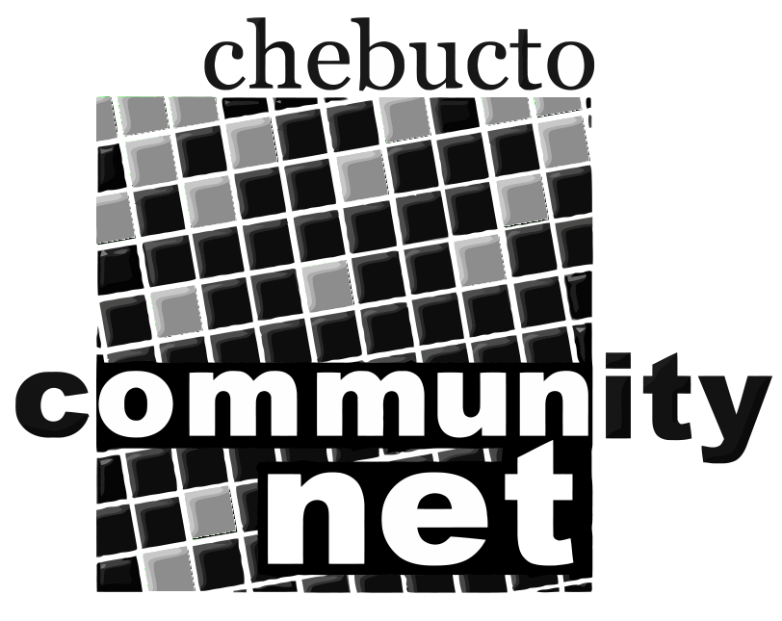 | Chebucto Community Net  Annual General Meeting  April 29, 2010
Policy Committee Report
The role of the Policy Committee is two-fold:
- to address policy development and implementation issues; and
- to address complaints or abuses about and by CCN members.
2009 was a very quiet year for the Policy Committee. No new policies were needed and none of the existing ones required amending.
The only reported cases of abuse from Chebucto members came from a couple of members' accounts being compromised by overseas criminals. Access to their accounts came from the users responding to scam emails claiming to be from Chebucto Community Net asking them for their password.
This sort of "phishing" email is almost impossible to completely block so all we can do is advise our users that we will never send out email asking you for your mail passwords and hope you all remember this message the next time an almost convincing email comes in telling about a security reset or other excuse to ask you for your private password. Never give out your password no matter what an email says, ever.
False spam reports from AOL users marking legitimate Chebucto email as spam continue to trickle in. We have kept below their blacklisting threshold so there were no functional problems caused by these false reports.
As in previous years we are looking for people interested in serving on the Policy Committee. Interested parties can submit their names to office@chebucto.ns.ca.

Andrew D. Wright

