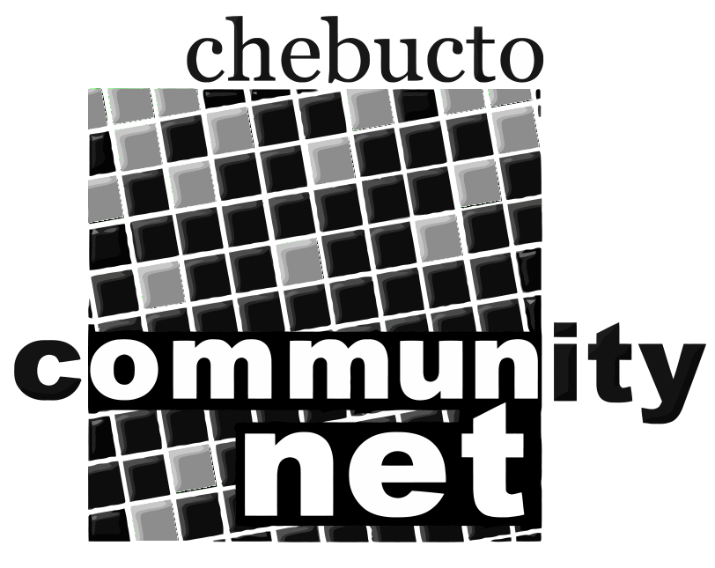 | Chebucto Community Net  Annual General Meeting  April 29, 2010
Agenda
1. Presentations: The Digital Divide in Nova Scotia, Fiber Alternatives.

2. Call to order

3. Minutes of the 2009 Annual General Meeting

4. Report from the Chair

5. Report from Policy Committee and Technical Report

6. Treasurer's Report

7. Election of Directors

9. Appointment of Auditor

10. Other business

11. Adjournment

